Software Requirements Specification:
Adaptive Health

Student/Team Name: Omar Massoud, Abdallah Heggy, Ghina Ishaq, Hamza Al
Raga,Bithin Radhakrishnan, Karylle Ochave Student Number:7858681, 8457785, 871179, 7322586, 8910881, 7669057
TEAM PULSE

Table of Contents

- Introduction .....................................................................................................................
  - Purpose ...................................................................................................... 1.2. Notation ......................................................................................................
  - Scope .........................................................................................................
  - Context Diagram ........................................................................................
  - Definitions and Acronyms ...........................................................................
  - References .................................................................................................
  - Overview .....................................................................................................
- General Description ...........................................................................................................
  - System Functions ..........................................................................................
  - User Characteristics........................................................................................
- General Constraints ...........................................................................................................
  - Software Constraints .......................................................................................
  - Hardware Constraints ......................................................................................
- Assumptions and Dependencies ......................................................................................... 5. Functional Requirements Master List ..................................................................................
- Functional Requirement REQ-1.1 .................................................................................
  - REQ-1.1 - Real-Time Heart Rate Monitoring.............................................
  - REQ-1.2 - Adaptive AI Exercise Feedback...........................................................................
  - REQ-1.3 - Emergency Alert System................................................................................
  - REQ-1.4 - Data Visualization Dashboard..................................................................
  - REQ-1.5 - User Authentication and Data.................................................................................
- External Interface Requirement ....................................................................................
  - Data Interface ............................................................................................... 7.2. User Interface ...............................................................................................
7.3. Other Interfaces .............................................................................................
- Non-Functional Requirements .....................................................................................
  - System Performance .......................................................................................
  - Information Security ........................................................................................
  - Availability ...................................................................................................
  - Capacity ....................................................................................................

1. Introduction

1.1. Purpose
This System Requirements Specification (SRS) defines the system's functional and non-functional requirements for Adaptiᴠ Health. This is an exhaustive outline of how the system will provide safe cardiovascular exercise through real-time feedback, AI analysis, and incremental, adaptive suggestions.
This SRS is relative to previously established documents such as the Business Requirements Specification (BRS), the Planning and Feasibility Analysis and the Project Proposal. Thereafter, this SRS will serve as the technical reference for:
- Creation of the High Level Design (HLD) document.
- Creation of the Low Level Design (LLD) document.
- Integration, testing and deployment implementation.
- Baseline documentation for stakeholder (students, mentor, clinicians and future industry partners) communications.

1.2. Notation
This document conforms to the following general notations applied in software-engineering documentation:
- UML Diagrams (Use-Case, Component, Sequence). \ (Figure 1 - Heart Rate Sequence with System Constraints represents the entirety of the data flow with user - wearable - app - cloud - dashboard.)
- Requirement Numbering. General functional items are categorized with REQ; performance REQ are PERF. Where there are extended security, availability and capacity REQs these are noted as SEC, AVA, CAP.
- Data Flow. Data flow is established between BLE → Mobile App → Cloud (AWS RDS/Firebase) → Dashboard.

1.3. Scope
Adaptive Health is an IoT, mobile app, cloud analytics and clinician dashboard system for safer exercise. It collects heart-rate, SpO₂ and HRV data from medical grade wearables in real time, performing edge AI on the smartphone for instantaneous (less than a second) notifications with ancillary cloud AI for long-term assessments. It provides wearers with an adaptive workout plan and graphical overviews of their performance while clinicians receive HIPAA secured access to a patient's web-based dashboard. Data is stored in accordance with GDPR and DHA health data regulations.

1.4. Context Diagram
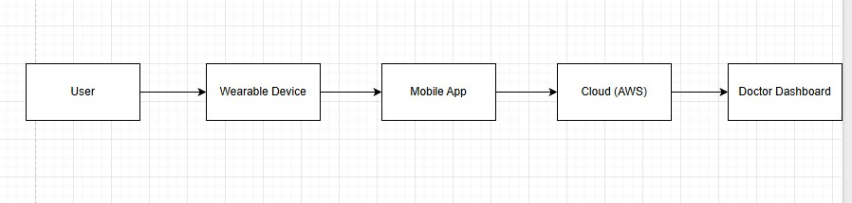

1.5. Definitions and Acronyms

This section describes any terms used.
IoT – Internet of Things; connected sensors and wearables.
BPM – Beats Per Minute (heart rate).
SpO₂ – Oxygen saturation level.
HRV – Heart-Rate Variability.
PHI – Protected Health Information.
HIPAA – U.S. Health Information Privacy Law.
GDPR – EU General Data Protection Regulation.
DHA – Dubai Health Authority (UAE health data law).
Edge AI – AI running locally on the device.
Cloud AI – AI processing on cloud infrastructure.

1.7. Overview
This paper spells out what Adaptive Health should do and how it should do it.
Section 2 Choice of system functions and users.
Section 3 Software and hardware limitations.
Section 5 Other assumptions and dependencies.
Summary of functional requirements.
Section 6a Detailed functional requirements.
Section 7 Exterior interfaces and connections.
Section 8 Non-functional performance, security, availability and capacity.
These sections together form a whole technical basis of the Adaptive Health project.

2. General Description

2.1. System Functions
Adaptiv Health combines wearable IoT, artificial intelligence, and cloud analytics to deliver safer and smarter cardiovascular care. The system operates through several interconnected functions that work in real time to monitor, analyze, and adapt to the user’s condition.

Continuous Physiological Monitoring: Wearable devices such as Fitbit, Apple Watch, and Polar H10 provide real-time measurements of heart rate, oxygen saturation, and blood pressure. These readings are transmitted to the mobile application through Bluetooth, where the data is cleaned, checked for missing packets, and formatted for analysis.

Adaptive Exercise Recommendations: The AI engine evaluates the user’s cardiovascular data and adjusts exercise recommendations automatically. When vital parameters exceed safe limits, the system sends immediate guidance such as “slow down” or “take a break” to reduce overexertion and maintain heart safety.

Alerts and Safety Notifications: Real-time visual, audio, or vibration alerts are triggered locally on the device using edge AI. The alerts appear within milliseconds, even when the network connection is weak, ensuring the user is immediately informed of potential risks such as arrhythmia or hypoxia.

Data Visualization and Post-Session Summary: The application displays live data on interactive dashboards with color-coded zones such as green for safe, yellow for caution, and red for high risk. After each session, a summary report provides details such as the highest recorded heart rate, recovery speed, and total time spent in the optimal zone.

Cloud Analytics and Long-Term Insights: All recorded data is securely encrypted and synchronized with the cloud using HIPAA-compliant platforms such as AWS, RDS, and Firebase. Over time, the system analyzes these records to detect trends, improvements, or early signs of potential cardiac issues.

Personalized Dashboards: The dashboard shows all system elements, showing personalized progress charts, health recommendations, and performance insights. Access is role-based; patients, doctors, and administrators only view information relevant to their needs, ensuring both privacy and usability.
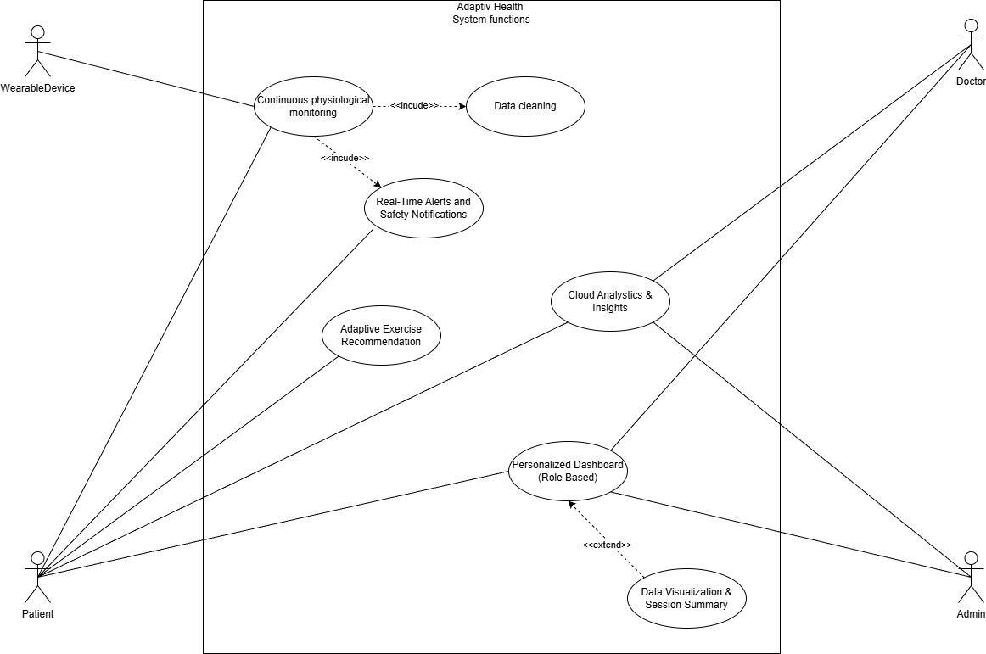

2.2. User Characteristics
Adaptiv Health is made for a wide range of users, each of whom interacts with the system differently based on their function and level of technical proficiency. The program makes sure that every kind of user has an interface that meets their demands while preserving data security and usability.

End users and patients:
People recovering from cardiac surgeries or those with mild to severe cardiovascular problems are the main users. They assess their daily progress, get adaptive workout instruction, and measure their vital signs using wearable technology and the mobile app. The majority of patients should be comfortable using smartphones and health-tracking gadgets and have a moderate level of digital literacy. The system has straightforward instructions, graphic indicators, and easy onboarding procedures to help less tech-savvy individuals.

Physiotherapists and clinicians:
The web-based dashboard allows medical personnel to monitor patient progress, spot cardiovascular trends, and adjust rehabilitation regimens. They are more technically proficient and have more experience deciphering digital health data. Accuracy and efficiency are the main goals of the clinician interface, which offers safe access to comprehensive graphs, summaries, and warnings pertinent to patient care.
Family members and caregivers:
With the patient's permission, caregivers are always given restricted access. In order to monitor or support the user during recuperation, they can view alerts and brief summaries. The interface that caregivers see is simplified, displaying only the most important information, like notifications and status updates, because many of them might not be familiar with sophisticated technology.
System Administrators and Technical Staff:
Account management, system integrity, and cybersecurity are within the purview of administrators. They handle user permissions, backups, and data protection compliance mostly through the admin web console. These users usually possess advanced IT skills and have received training on healthcare security regulations like GDPR and HIPAA.
Overall, Adaptiv Health operates on several platforms, including a wristwatch interface for real-time monitoring and notifications, a web dashboard for physicians and administrators, and a mobile app for patients and caregivers. The system's interface, iconography, and guided setup make it simple to use for people of all ages and ability levels, even though some experience with digital devices is anticipated.

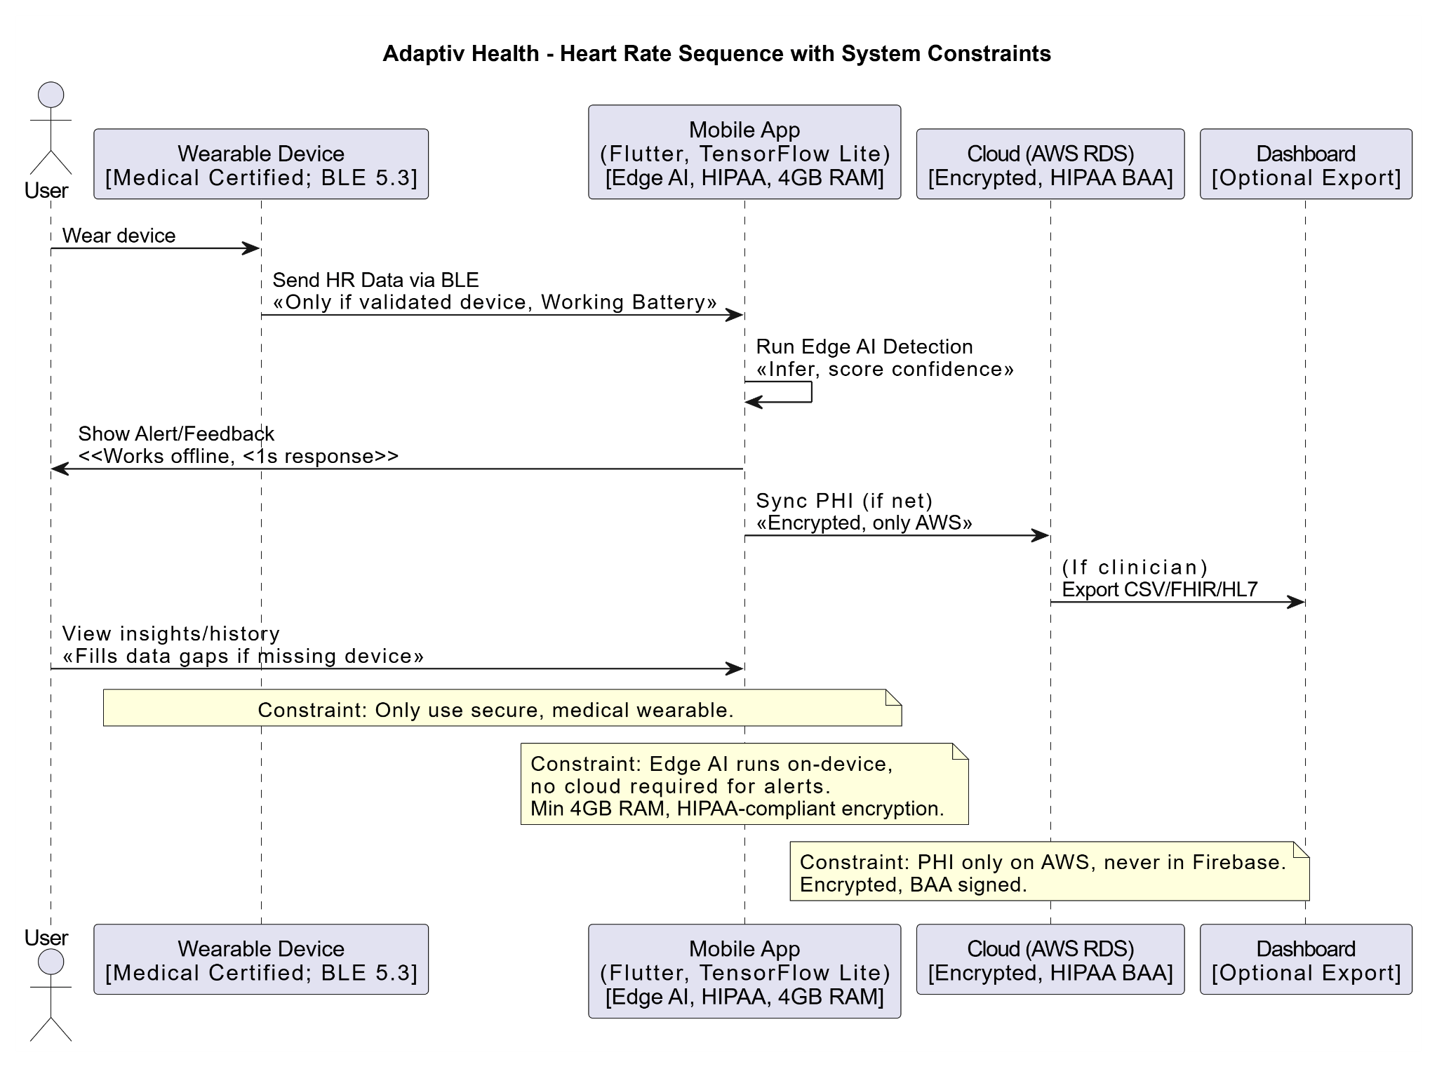

3. General Constraints
Our project has its own constraint that needs to be met due to limitations of time and coursework. Other than that, there are several social, technological constraints that we need to keep in mind to meet the requirements for our project. Some challenges that put up the constraints are wearable sensor accuracy across diverse populations, Health standards, data validation, comprehensive unified language, AI development for accurate data processing and understandability of processed information. They affect the three traditional constraints: scope, time and cost.

3.1. Software Constraints

3.1.1 Programming Language (Python 3.1x)
Python is the standard programming language used in AI and biomedical applications which is safe and meets HIPAA/GDPR standards. Introducing another language to this ecosystem would make it hard for people across all departments to manage. Python has a huge library in its database that is closely associated with software development healthcare needs which will in turn help with faster development of modules and its integration. We are hoping to use the latest available version of python for the added features and libraries available in the future upgrades.

3.1.2 AI Frameworks (Edge AI + Cloud AI)
We expect our project to continuously monitor data inputs and perform fast analysis in case of an emergency. This requires us to develop a light weight local AI model for in-app data processing within the smartphone on top of the cloud AI which will do a deeper analysis of trends and machine learning. TensorFlow Lite is a fast, super lightweight, common in health care ecosystem, that works on android and iOS which is HIPAA compliant which can contribute as edge AI and do all critical emergency fast detection. TensorFlow combined with AWS and Firebase for cloud AI, storage, management and security. Our current knowledge on using TensorFlow for AI development is limited but we are hoping to train ourselves and be equipped enough to be able to start working on this project by next trimester.

3.1.3 Mobile App Framework (Flutter)
A project based on personal health info requires a high level of security and meets health standards. Maintaining multiple apps for different OS can create issues and increase chances of error. Flutter is a cross-platform with high level of security and strong Bluetooth LE support. You can safely store data locally with AES-256 encryption and fast smooth operation with a high-performance engine which lets you write code once for multiple OS and saves time.

3.1.4 Database and Cloud
All protected health information must be stored in a HIPAA compliant database. Non-sensitive data like user app customizations can be stored in Firebase which is faster for real time data synchronization as it has a built -in database manager however not HIPAA compliant. AWS RDS with PostgreSQL is HIPAA compliant storage for large structured safe health data. All data is secure and encrypted at rest so if compromised they won’t be leaked. It is standard and trusted by big wearable device companies and hospitals. Real time synchronization is slower with AWS RDS PostgreSQL. PostgreSQL is better for handling large groups of users and complex queries as compared to other NoSQL database storages.

3.1.5 Security Standards
There are mandated government rulebooks for security standards especially when it comes to health data protection. The US has HIPAA/GDPR rulebooks, following this is the best practice for global compatibility while UAE has federal laws and regulations for health data. Dubai Health Authority (DHA) regulates use of health information, violation of which can cause serious penalties and even imprisonment. DHA requires health data gathered in UAE to be localized and cannot be moved back and forth between servers. There must be specific commitment to all the UAE/DHA requirements in contracts. All the records are to be stored for at least 25 years to be DHA compliant.

3.2. Hardware Constraints

3.2.1 Wearable Devices
Heart recovery requires sharp capture of user metrics through smartwatches, smart wearables, bands or straps. All types of skin tones and exercises don’t work with every device. Proper measurements require wearables that are clinically/FDA approved. All the trusted alternatives could be suggested through the application. And if the application detects the device to be under performing and when data is not validated the app should prohibit the use of this device and suggest an alternative best fit for the user.

3.2.2 Mobile Devices
App download must be restricted to devices that meet minimum requirements such as BLE 5.0, 4G, 4GB RAM, internet connectivity and sufficient storage. This is to ensure the smooth running of the application in the mobile device. It required porter device-app connectivity, a good internet connection and the application should be able to run smoothly in the background. PPG measurement through the phone is risky for people with darker skin tone types as detection is done through passing of light and blood volume measurement. The feature can be enabled but should not be trusted for accuracy.

3.2.3 Network and Cloud
All critical emergency alerts working locally through edge AI must be able to operate when entering an area with no reception or data timeouts. Hourly summary of aggregated user physiological data payload is transferred to cloud AI for machine learning and user personalization for which internet connectivity is necessary. Missing data in the event of battery loss, or other such occurrence can be covered by KNNImputer tool from scikit-learn library that fills in missing data by taking the average of the nearest data points.

4. Assumptions and Dependencies

4.1 Assumptions

a) User engagement
Even though users are expected to provide steady data, most users are not regular users of smart devices; they sometimes forget to use the device or sometimes forget to recharge it. These holes are expected to be covered through imputation and send regular notification from apps that use the device so there is a steady flow of user data entry.

b) Data Quality Varies
We assume steady quality data for processing output. Output data is based on probability and depends entirely on the quality of the data. Data quality depends on user usage, device endurance, and other demographics or conditions. Users and doctors need to assume the data outputs are fair and accurate assumptions. The system is responsible for making sure the validity of the data acquired and ensuring users the reliability level of the output and informing when it is below standard. c) Network outage
A steady internet connection at all times. During a network outage the data is expected to be queued up until the next upload. The longer the upload is on hold the more the local data expansion. Upon next upload the services are expected to resume smoothly on cloud end. Such service disruptions hopefully don’t confuse edge AI with piling of old data. Proper coding to mitigate this will be done for proper segregation and timestamping data accumulated.

4.2 Key Dependencies and Regulatory Dependencies a) AWS and Other Cloud Providers
Health information is expected to be protected through AWS. In the event of AWS cost change, subscription cancellation, policy changes or license loss we might lose features. The system needs to be designed so PHI can be safely exported, and cloud services swapped for the next best provider. b) Wearables
Smart devices that record user data are trusted to provide quality data for processing. If the data is redundant or corrupted through a patch update this will ruin the personalization process for the user. Triggers can be set after enabling pattern recognition through machine learning for quality checks and discarding bad data.
c) Software/AI/ML Model Versions

All must be versioned since if a new version has a bug we can choose not to update or roll back after the update. All updates must be thoroughly checked and run before deployment. d) HIPAA/GDPR/DHA/FDA
All data must be protected. User information must be high priority as compromising can result in ransomware attacks, data stolen or data corruption. Regular risk assessments must be conducted and follow the legal procedures closely for any changes. Annual policy re-evaluation can ensure privacy laws are followed and deployed in accordance with it. Full government level review and approval will be necessary before a market launch as a product for hospital diagnosis assistance.

5. Functional Requirements Master List
This section lists the functional requirements in summary form. Each of these will be further defined in subsequent sub-sections.

Req. ID Requirement Name Requirement Description
REQ-1.1

Req. ID | Requirement Name | Requirement Description
REQ-1.1 | Real-Time Heart Rate  Monitoring | Constant recording and monitoring of heart-rate of wearable sensors.
REQ-1.2 | Adaptive AI Exercise  Feedback | Individualized responses modulating exercise intensity on physiological data.
REQ-1.3 | Emergency Alert  System | Monitors the presence of abnormal readings and sends emergency alerts.
REQ-1.4 | Data Visualization  Dashboard | Shows data trends and summaries as charts and graphs.
REQ-1.5 | User Authentication and Data Encryption | Secures the information of users by using secure password and encryption.

6. Functional Requirement REQ-1.1

6.1 REQ-1.1 – Real-Time Heart Rate Monitoring

6.1.1 Description
The wearable device should constantly monitor the heart rate of a user in the app. The idea is to present the existing BPM on the screen with the least delay.

6.1.2 System Input
Information on the smartwatch or chest strap (such as a Fitbit Charge 6 or Apple Watch 9) transmitted via the Bluetooth Low Energy connection.

6.1.3 Display
A small line chart that changes after every few seconds and a numeric value will be displayed on the screen. When the heart rate becomes excessively slow or fast the colour is altered to provide a warning.

6.1.4 System Processing
It gathers the sensor one time a second, filters noise, turns the signal into beats per minute, and records a timestamp locally before sending the information to the cloud.
6.1.5 System Output
The BPM, user ID and timestamp are transmitted to the cloud as well in the form of JSON.
6.1.6 Constraints
Bluetooth connection should be active; it should be between -2 and +2 BPM.

6.1.7 Error Handling
In the event the device takes 10 seconds without transmitting data, a message appears to notify the user to
ensure the connection is working. It will resend a couple of times and then it will surrender.

6.2 REQ-1.2 – Adaptive AI Exercise Feedback

6.2.1 Description
This is a personalised exercise advice, which suggests the intensity of the workout in case the live health data indicate to the user that the readings are excessively straining.
6.2.2 System Input
Heart-rate, heart-rate variability, oxygen saturation and personal information such as age and risk level.
6.2.3 Display
A fast message or icon is shown, which instructs the user to either add more or less effort.

6.2.4 System Processing
A mobile lightweight machine-learning model analyzes the information and provides a risk rating between 0 and 1. In case the score is high, the app will recommend to slow down or take a break.
6.2.5 System Output
The cloud stores the feedback which is subsequently displayed on the dashboard.
6.2.6 Constraints
Should take less than two seconds and should take place only when the battery is more than 75.

6.2.7 Error Handling
In the event of an AI malfunction, the application will resort to plain rule based limits e.g. “in case HR > 120 BPM - slow down.”

6.3 REQ-1.3– Emergency Alert System

6.3.1 Description
It is the section that addresses emergencies. In case of dangerous readings, alerts are given to the doctors or family members immediately.
6.3.2 System Input
Heart rate, SpO₂, HRV, and individual safe limits of every user.
6.3.3 Display
The screen red lights up and there is a loud alarm signaling that there is an emergency.

6.3.4 System Processing
These values are compared by the cloud after every few seconds; the problem is considered critical when it lasts longer than 15 seconds.

6.3.5 System Output
One is sent an automatic message to the contacts that are listed and the dashboard of the doctor. The event is also logged.
6.3.6 Constraints
The alerts should be emitted within 3 seconds in case the network is alive.

6.3.7 Error Handling
The app will save the alert to the local disk and will continue to make attempts in the future in the event that the internet is unavailable.

6.4 REQ-1.4 – Data Visualization Dashboard

6.4.1 Description
All the received health data are displayed on the dashboard in charts to help the users and doctors notice the trends easily.
6.4.2 System Input
Information that is obtained in the cloud database that contains daily and weekly summaries.

6.4.3 Display
Both the web portal and the mobile application have simple tabs of Heart Rate, Oxygen, Activity Score and Alerts. Physicians are able to compare and export patients.

6.4.4 System Processing
The server will take out the data and format them before sending back to the app in the form of ready-to-draw chart data.
6.4.5 System Output
Graphs, charts, CSV or PDF downloadable reports.
6.4.6 Constraints
Should open up to two seconds in phones and 5 inches and above in screens.

6.4.7 Error Handling
In case the data cannot be loaded, the dashboard indicates the last available data with a notice that it is waiting to sync.

6.5 REQ-1.5 – User Authentication and Data Encryption

6.5.1 Description
This functionality ensures the security of the health data of the user as it will need to log in and encrypt data all the time.
6.5.2 System Input
Email and password/ Google/Apple ID login.

6.5.3 Display
Login page also provides the fingerprint or one-time SMS code. On the three attempts that fail, the account is locked off (5 minutes).

6.5.4 System Processing
The credentials are verified using Firebase Auth, a secure session token is generated, and all traffic is encrypted using the TLS 1.3 and AES 256.
6.5.5 System Output
The authentication generates a safe session, and the system records the time of login and the ID of the device.
6.5.6 Constraints
The sessions are timed out after 30 minutes of being inactive.

6.5.7 Error Handling
Errors such as invalid credentials or session expired will be shown and every unsuccessful attempt will be recorded to be examined.

7. External Interface Requirement

7.1 Data Interfaces
Adaptiv Health is built upon a multi-tier data flow system that standardizes wearable devices, mobile apps, and secure cloud infrastructure.
- Wearable Sensors → Mobile App:
The information, including the heart rate (BPM), oxygen saturation (SpO₂), and blood pressure, is relayed through the Bluetooth Low Energy 5.3 to the Flutter-based mobile application. The application does some basic data validation and compression and then passes it on.
- Mobile App → Cloud (AWS + Firebase):
The application interacts with the cloud in a secure way with TLS 1.3 encryption.
○ Firebase/Firestore: deals with real-time synchronization of non-PHI data (e.g., workout progress, steps).
○ AWDS RDS PostgreSQL: contains the Protected Health Information (PHI), encrypted by AES-256 in accordance with the HIPAA Business Associate Agreement (BAA).
○ AWS EC2 API Servers: analyze processes, rate them, and provide suggestions through AI in close to real-time.
- Cloud → Doctor Portal (React Dashboard):
Analytics, risk alerts, and session histories are available to physicians on a HIPAA-compliant dashboard that is linked to a secure REST API using role-based access control (RBAC).
- Edge AI Feedback Loop:
TensorFlow Lite models deployed on-device handle local inference to generate instant alerts (<160 ms latency), while summarized statistics are uploaded daily for cloud learning and long-term tracking.

7.2 User Interfaces
Adaptiv Health is based on medical-grade UI design standards (WCAG 2.1, HIPAA-accessible). Interfaces are focused on the simplicity, the minimalism, and the ease of use of interfaces with all ages and technical skills.
● Mobile Application (Flutter 3.24):
○ Main Dashboard: This has a real-time heart rate (60 fps), safe zone (green/yellow/red), and current activity.
○ Alerts: Voice or visual prompts (e.g., “Heart rate too high—slow down”).
○ Reports Page: Daily summary charts (HRV trends, recovery time, total activity).
○ Settings: Sharing of data, privacy, and pairing of devices.
● Doctor Dashboard (React 19.2):
○ Patient List View: Displays heart rate patterns, alerts, and summaries.
○ Patient Details: Interactive graphs, anomaly detection, and AI recommendations.
○ Alerts Panel: Prioritized list of high-risk events detected by the AI.
○ Access Control: Login protected with OAuth 2.0 and multi-factor authentication.
● Accessibility Features:
○ Adjustable font sizes and contrast modes.
○ Voice prompts for elderly or visually impaired users.
○ Intuitive navigation with limited technical input required.

7.3 Other Interfaces
Interface Type | Description
Hardware  Interfaces | Supports commercial wearables (Fitbit Charge  6, Apple Watch Series 9, Polar H10,  ESP32+MAX30102). Devices connect via BLE  5.3 for low-latency, energy-efficient data transmission.
Software  Interfaces | Integration with Google Fit API, Apple  HealthKit, and AWS SDKs for seamless health data exchange and synchronization.
Communication  Interfaces | Uses HTTPS with TLS 1.3 for all client-server communications. MQTT optional for IoT real-time data streaming.
Security  Interfaces | Endpoint protection via CrowdStrike Falcon, cloud security by Zscaler/Prisma Cloud, and Darktrace ActiveAI for anomaly detection.
Backup &  Recovery | AWS S3 with Object Lock and immutable snapshots ensures no data loss during failures or ransomware events.

8. Non-Functional Requirements

8.1 System Performance
Req. ID | Description | Response Time / Target
PERF-1.1 | Time for user navigation between standard screens (e.g., from Dashboard to Reports). | ≤ 1 second
PERF-1.2 | Time for the system to process and display new session data or health summaries. | ≤ 3 seconds
PERF-1.3 | Time for AI-based analysis and cloud update after session completion. | ≤ 7 seconds
PERF-1.4 | Time for synchronization between mobile device and cloud servers. | ≤ 2 seconds for edge-to-cloud updates; ≤ 24 hours for full data backups
PERF-1.5 | Real-time heart rate and SpO₂ updates displayed on mobile. | ≤ 0.5 seconds (500ms) latency

8.2 Information Security

Req. ID | Description
SEC-1.1 | All sensitive data (user credentials, health data) must be encrypted in transit (TLS 1.3) and at rest (AES-256).
SEC-1.2 | PHI must only be stored in HIPAA-eligible cloud environments (AWS RDS, EC2, S3) that have passed full testing.
SEC-1.3 | The system shall comply with HIPAA, GDPR, and UCL Information Security Policies equivalents.
SEC-1.4 | Use OAuth 2.0 / OpenID Connect for authentication with RBAC and token rotation every 24 hours.
SEC-1.5 | Implement Darktrace ActiveAI for intrusion detection and ManageEngine DLP+ for data-leak prevention.
SEC-1.6 | Data anonymization and “right-to-be-forgotten” features for users per GDPR Article 17.

8.3 Availability
Req. ID | Description
AVA-1.1 | System uptime must be at least 99.5% excluding planned maintenance.
AVA-1.2 | Planned maintenance shall not exceed 4 hours per month and occur during off-peak hours.
AVA-1.3 | The system shall automatically recover from transient server failures within 30 seconds via AWS Auto-Scaling.
AVA-1.4 | Redundant servers (multi-region AWS deployment) must ensure data accessibility even during outages.

8.4 Capacity
Req. ID | Description
CAP-1.1 | System must handle 100,000 patient records in year one.
CAP-1.2 | System must handle 250,000 patient records in year two.
CAP-1.3 | System must handle 500,000+ patient records in year three.
CAP-2.1 | Support at least 10,000 concurrent workout monitoring sessions in year one.
CAP-2.2 | Support at least 50,000 concurrent users by year two.
CAP-2.3 | Support at least 100,000 concurrent users by year three.
CAP-3.1 | Cloud storage shall scale automatically through AWS S3 lifecycle
 | management and database sharding.

References

- HIPAA Law
Health Insurance Portability and Accountability Act of 1996, Pub. L. No. 104-191, 110 Stat. 1936 (1996).

- Dubai Health Data Law / DHA
Dubai Health Authority. (2022). Policy for Health Data Protection and Confidentiality (HISHD/PP-11). https://www.dha.gov.ae

- AWS HIPAA-Eligible Services
Amazon Web Services. (2025, November 5). HIPAA compliance - Amazon Web Services (AWS).
https://aws.amazon.com/compliance/hipaa-compliance/

- KNNImputer/scikit-learn
Géron, A. (2019). Hands-on machine learning with Scikit-Learn, Keras, and TensorFlow:
Concepts, tools, and techniques to build intelligent systems (2nd ed.). O’Reilly. scikit-learn developers. (2024). KNNImputer — scikit-learn documentation.
https://scikit-learn.org/stable/modules/generated/sklearn.impute.KNNImputer.html

- Flutter
Google. (2025, October 31). Flutter documentation. https://docs.flutter.dev

- TensorFlow
Abadi, M., et al. (2015). TensorFlow: Large-scale machine learning on heterogeneous systems. Software available from tensorflow.org.

